
Forest School Handbook

Markethill Primary School
Conservation Area
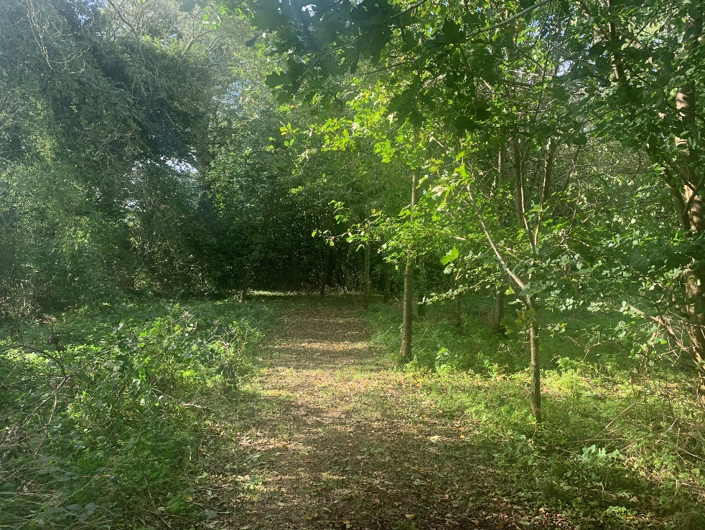

Contents
Page 3 Welcome to Forest School
Page 4 Guidance for Volunteers
Page 5 Emergency Procedure
Page 6 Procedure in case of a participant going missing/absconding
Page 7 Health & Safety Policy
Page 8 Site Safety
Page 9 Risk Assessment Policy
Page 9 Staff and Pupil Ratio
Page 10 Travel and Transport Policy
Page 10 Walking and Roads Policy
Page 11 Behaviour Policy
Page 12 Child Protection Policy
Page 13 Equal Opportunities Policy
Page 14 Equipment – Tools/Forest School Leader’s Equipment
Page 15 Toilet Protocol
Page 15 Insurance
Page 16 Impact of Forest School on the Woodland
Page 17 & 18 Appendix 1 Risk Assessment Form
Page 29-28 Appendix 2 Risk Benefit Form
Page 29 Environmental Impact Form
Page 36 Contacts

Welcome to Forest School
Forest School is an educational programme developed from Danish ideas of working with children and young people in the outdoors, helping to build self-esteem, social skills and independence. Hands-on activities with natural materials develop practical and intellectual skills, which can be linked to the National Curriculum. Forest School aims to boost confidence through setting students up to succeed. Tasks are broken down into small achievable chunks that are matched to students’ capabilities.
In addition, Forest School helps children become part of an effective efficient team and to participate in a range of creative, sensory and environmental awareness activities.
Forest School uses children’s learning styles as a basis for the presentation of all activities. Children who learn visually can access learning through the demonstrations. All activities are presented through speech for those children who learn aurally. Freedom to touch, feel and “do” satisfies the kinaesthetic learner.
This pack contains information for staff, volunteers and parents of children helping with the Forest School Programme.
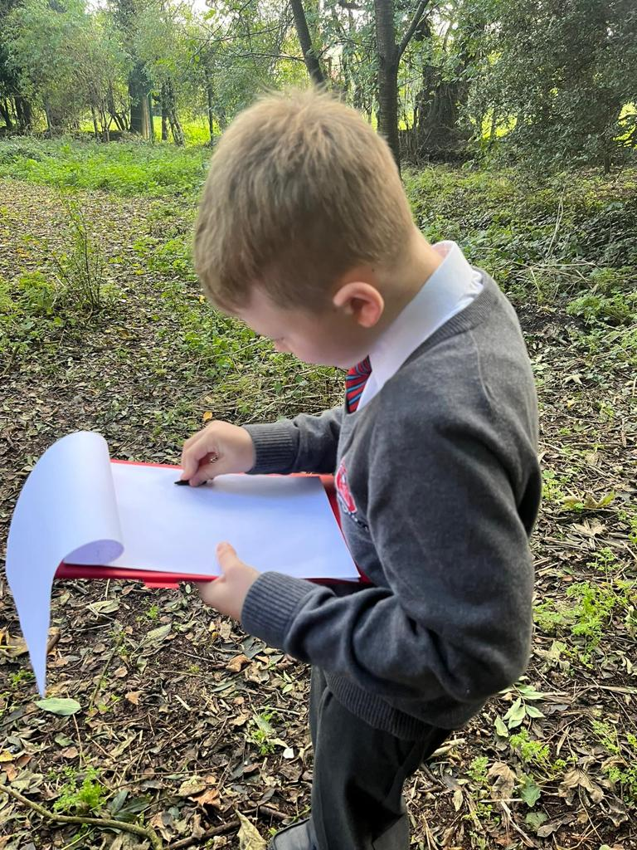

Forest School – Guidance for Volunteers
Forest School welcomes the opportunity to work with you. Volunteer adults are vital and essential. Included are some guidelines to make this a valuable experience for all.
Please:
- Ensure that you are appropriately dressed for the weather conditions of the day.
Many Forest School activities involve getting damp and muddy. See clothing list below.
- Inform the team of any medical conditions or allergies that may affect you during the Forest School session.
- Complete the Volunteer Helper Information Form.
- Familiarise yourself with the policies in this handbook.
- Feel free to ask any questions. The Forest School team will be happy to explain the Forest School ethos and aims of each session.
- Maintain confidentiality.
- Assist the leader in helping the children to maintain their own and others’ safety.
- Report accidents, hazards and equipment defects to the leader.
Your co-operation regarding requests and instructions from the Forest School staff is greatly appreciated.
Please note that it is Forest School Policy to carry out an AccessNI Check before you can visit the woodland with the children.
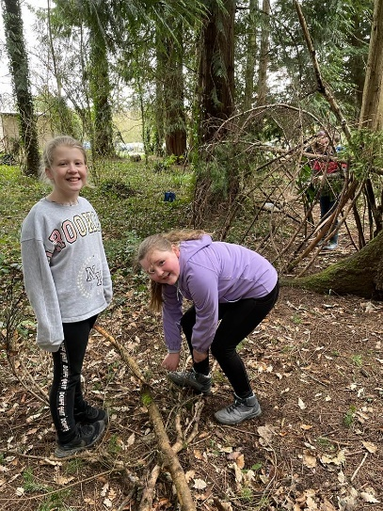
Clothing list
- Waterproof clothing – jacket and trousers
- Woolly hat, or sun hat depending on season
- Gloves
- At least 1 jumper – layers of clothing are useful for regulating body temperature
- Long sleeved top even in summer
- Warm socks in winter
- Wellington boots or walking boots or sturdy trainers with good grips.
NOT ADVISED
- Scarves are not advised at Forest School due to risk of entanglement.
- Shorts are not allowed
- Skirts which cover all the legs are allowed if required for cultural reasons.

Emergency Procedures

All participants will be briefed in what to do in case of emergency. A whistle blast will signal that everyone must stop what they are doing, gather by a member of staff, be silent and await instructions.

Listed below are the procedures that will be adopted in case of emergency or unforeseen circumstances:
In case of injury:
If anyone sustains injury or illness which cannot be treated by first aid on site, and requires removal to hospital or a doctor:-
- If severity requires it, 999 is dialled using the mobile phone carried by the Forest School Leader. The remainder of the group should be contained together away from the incident site and involved in a meaningful static activity.
- One member of staff should meet the ambulance at the main entrance to the school or wood and direct the crew to the incident site.
- In minor cases the Forest School Leader will be responsible for contacting the parent/carer of the casualty so that they can collect the child and drive them to hospital or doctor or home.
- If the latter is not possible, as a last resort the teacher/group leader must use their own car. Two members of staff should be in a car which is insured for work purposes.

Please refer to Useful Contact Numbers at the back of this handbook.
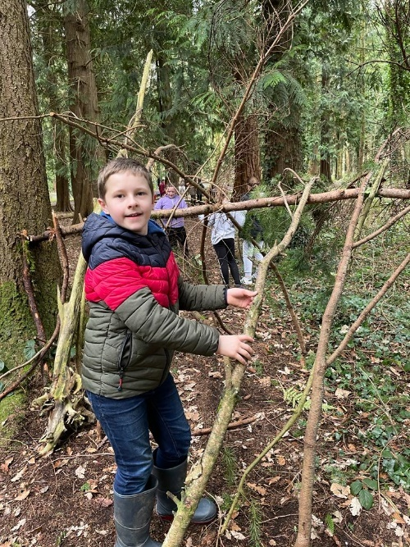

Procedure in case of a participant going missing/absconding

As soon as it is discovered that a child is missing, the situation will be considered an emergency.
- As such, after no more than 5 minutes of calling and cursory looking for the missing person, a detailed adult will contact the school, the police and the child’s contact number.
- Maintaining the correct adult/child ratio, any surplus will be deployed to search for the child.
- The remainder of the group should be contained together away from the last known position and involved in a meaningful static activity.
- Staff should meet and corroborate details of the situation, last known position of the person etc.
- Return to the Last Known Position and mark it immediately.
- All prints found should be marked.
- Do not stand on any prints.
- If the person has not been located the police should be called again and asked to attend the scene. The time when this action is taken will depend on the specific situation and will be judged by the Forest School Leader.
- Whilst waiting for the police to arrive, tracking should continue as before.
- Under no circumstances should other children be used s searchers.
- One member of staff should meet the police at the entrance to the site and direct them to the Last Known Position.
- Staff should then follow the directions of the Police Search Advisor.
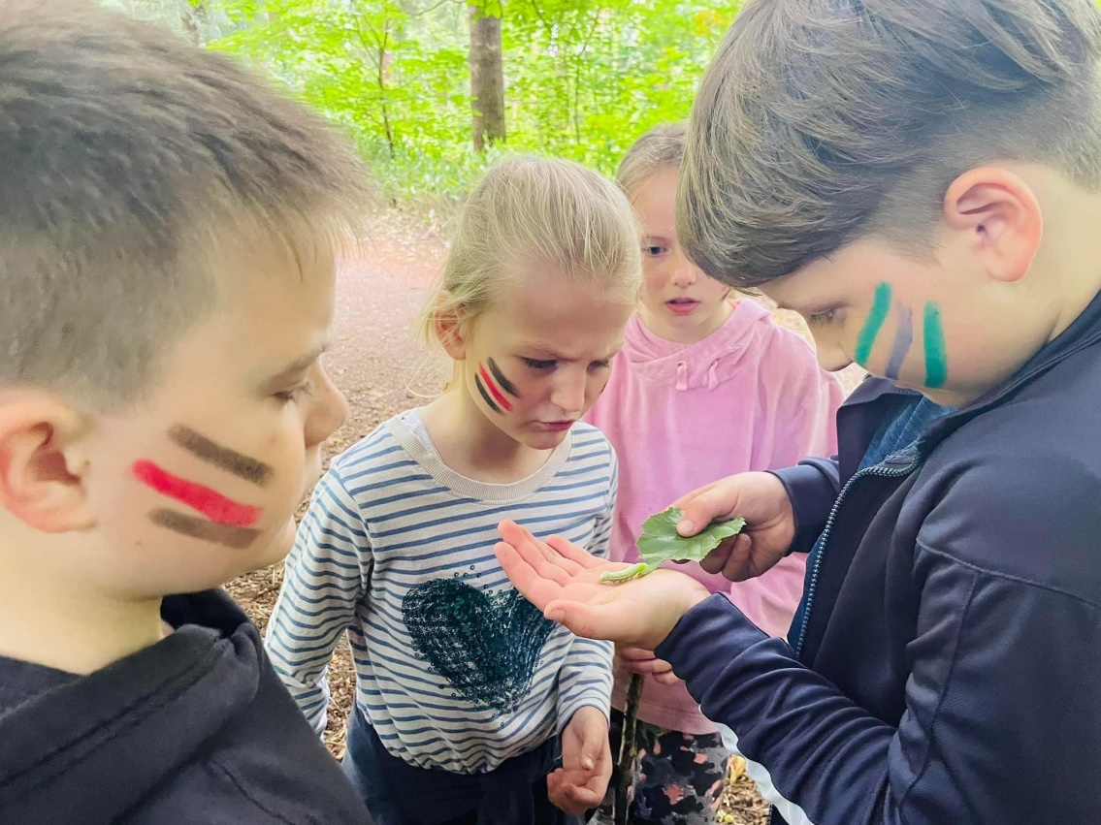

Health and Safety Policy
The Forest School Leader will endeavour to provide and maintain a safe learning environment and involve all participants in becoming aware of and reporting any potential hazards. Learning about perceived and actual risk is an important aspect of outdoor learning and is incorporated into all activities where practical.
Written risk assessments are undertaken regularly for the areas used for Forest School activities. See Appendix 1.
A visual risk assessment will be undertaken prior to each session and any new hazards will be noted on the risk assessment form.
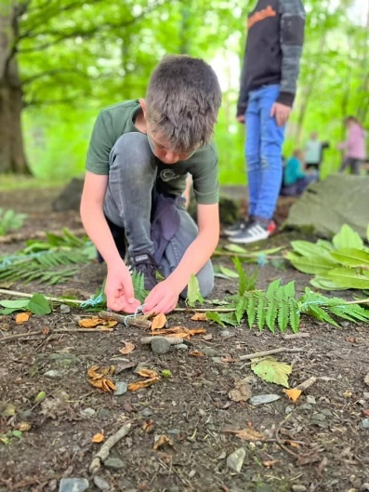
These will be filed and held by the Forest School leaders.
Procedures for emergency situations are included in this file. Please familiarise yourself with these before participating in a session.
The Forest School Team will
- Teach children and adults to maintain their own and others’ safety, involving them in risk assessments and safe inspections.
- Maintain the legal adult: child ratio.
- Ensure equipment meets required standards and is maintained and used appropriately.
- Assume responsibility for the maintenance of the First Aid Kit and other safety equipment.
- Record any incident involving an injury, missing person or allegation of misconduct as soon as possible after an event.
- Regularly monitor the effectiveness of policies and working practices, revising and amending as necessary.
The children, to the best of their capabilities, will:
- Exercise personal responsibility for the safety of themselves and others.
- Observe the safety information with which they have been provided.
A copy of the school’s Health & Safety Policy can be found in the Principal’s office.

Site Safety
The following checks and precautions will be carried out in order to ensure safety at the Forest School site.
- Pre-visit checks will be carried out to ensure the site is free of dangerous litter, refuse, dog and cat excrement, also that there is no damage from fallen trees of hung up branches.
- A session may be cancelled if, in the opinion of the Forest School Leader, weather conditions, such as high winds make visits to the forest unsafe or, if due to staff absence, the appropriate ratios cannot be maintained.
- During very wet weather a shelter will be put up on the school site.
- A risk assessment is carried out for all activities. See Appendix 1.
- All participants will have access to drinking water during sessions.
- During some sessions food will be cooked on a campfire and eaten. Basic hygiene standards will be followed such as cleaning hands before food and using food within sell-by dates.
- During some sessions a fire will be lit using a pre-prepared fire pit. The children are gradually introduced to and taught valuable skills regarding fire safety. They are shown how to approach a fire carefully and how to treat it with respect. They are shown how to put the fire out at the end of the session.
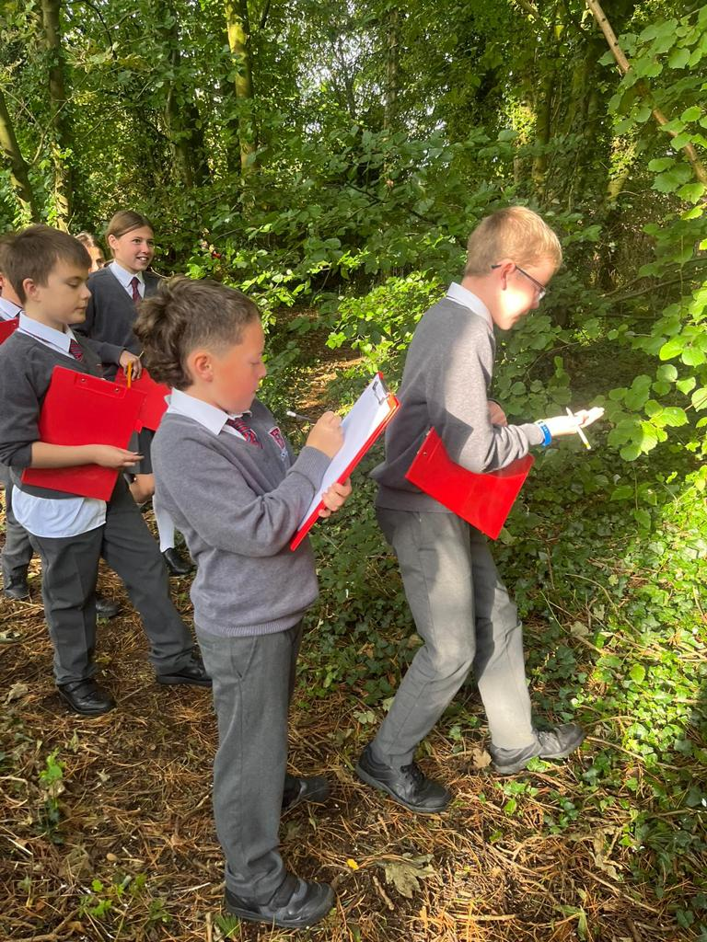

Risk Assessment Policy
The safety of all children is paramount. In order to achieve this, the Forest School leader will:
- Recognise that a hazard is anything with the potential to cause injury or harm.
- Identify significant hazards and ensure risks are minimised, taking appropriate action as necessary.
- Carry out regular and continuous risk assessments of working areas. See Appendix 1.
- Be constantly alert to potential, previously unidentified risks.
- Complete risk assessment paperwork.
- Inform staff, volunteers and children of potential risks and methods to minimise them.
- Involve staff, volunteers and children in risk assessment, as appropriate, as part of learning.
- Ensure legal guidelines regarding off-site activities, such as adequate insurance, permission and records are met.
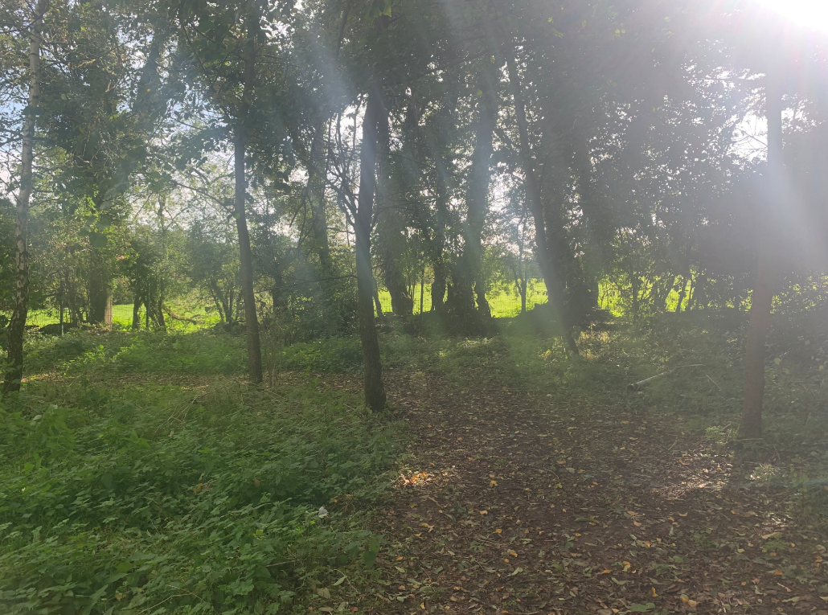
- Implement emergency procedures as necessary.

Staff and Pupil Ratios
Due to the nature of Forest School activities, high ratios of adults to children are necessary in order to ensure a safe, high quality learning environment at all times. The minimum ratio of adults to children is 1:6. This means at least two adults with training or experience of teaching/working with young people, for a group of ten children. This ratio will need to be increased if any of the children have special needs that require extra attention.
If the group is working with tools or fire the minimum ratio is 1 adult to 3 children.

Travel and Transport Policy
(Appliable if any Forest School session occur outside of the conservation area)
Forest School aims to ensure that all children and adults participating in the programme remain safe while travelling in the minibus. In order that this is achieved, the Forest School Leader will:
- Ensure that the driver of the minibus holds an appropriate licence in accordance with Education Board guidelines.
- Ensure that the minibus is covered by appropriate tax and insurance in accordance with Education Board guidelines.
- Ensure that the minibus is fit for purpose by performing basic safety checks including tyres, lights, seat belts and windscreen wipers. Ensure that the minibus undergoes regular garage servicing.
- Ensure appropriate supervision while travelling, making sure the driver is unavailable for a supervisory responsibility.
- Ensure that children and adults are fully aware of appropriate behavioural standards while travelling including keeping a low noise level, remaining in seats, not distracting the driver and not releasing seat belts until requested.
- Ensure that children and adults are aware of emergency procedures when travelling.
Walking on Roads Policy
(Not currently applicable as Forest School sessions will take place on school site)
The Forest School Leaders will ensure that:
- Supervising adults wear high visibility jackets.
- Children walk in an orderly, single file line.
- Children are reminded of the hazards of walking on roads.
- There is the correct adult:child ratio
  - 1:6

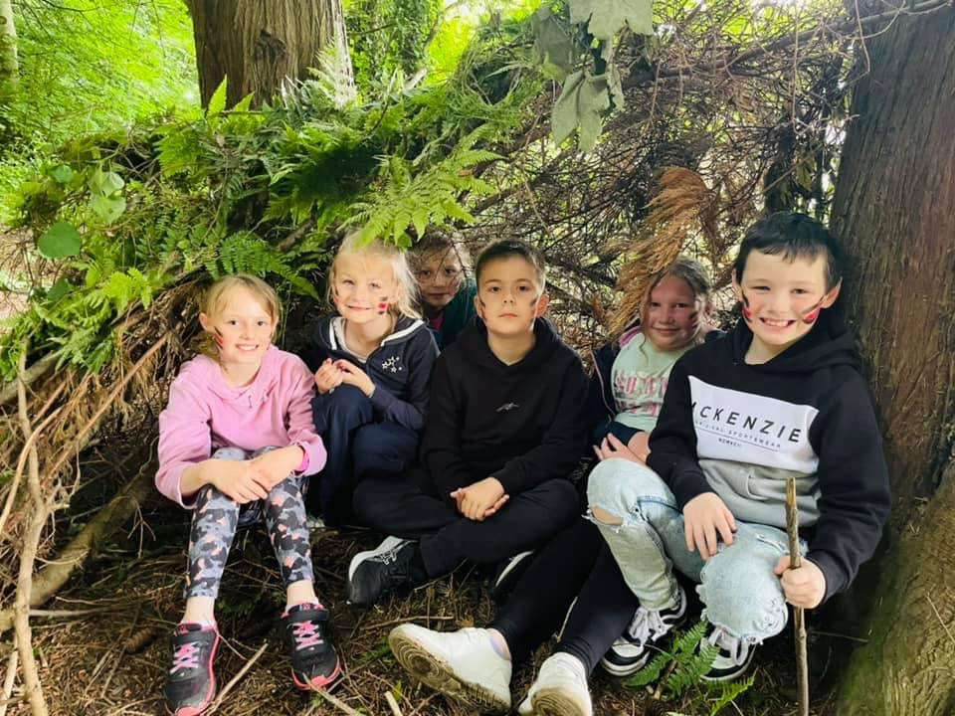

Behaviour Policy
Forest School aims to facilitate children’s self-esteem, independence and motivation to learn, while always maintaining a safe environment. In order that these goals are worked towards, certain standards of behaviour need to be sustained and reinforced. This policy clarifies responsibilities in this area:
The adults at Forest School will:
- Create a positive environment which encourages and reinforces caring, nurturing and acceptable behaviour towards each other, the environment and the equipment.
- Build effective relationships in which all are accepted, valued and treated equally.
- Be consistently mindful of the need to maintain safety.
- Clearly define and reinforce acceptable standards of behaviour.
- Respond consistently to both positive and negative behaviours.
- Consistently model high standards of behaviour.
- Place the needs of the children at the centre of the curriculum to minimise failure and maximise success.
The children, to the best of their capabilities will:
- Respond to requests, instructions or actions, particularly those concerning safety.
- Develop and maintain an acceptable attitude to each other, the environment and the equipment.
It may be necessary, after all possible avenues have been investigated, to exclude a child who is judged to persistently be compromising their own safety and the safety of other children and adults participating in the Forest School programme.
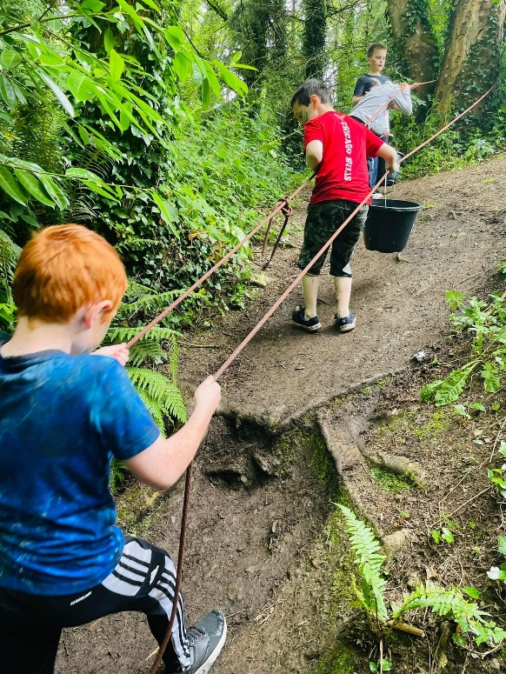

Child Protection Policy
The Forest School team fully recognises its responsibilities for child protection.
Our policy applies to all staff and volunteers working at Forest School. There are four main elements to our policy:
- Ensuring we practice safe recruitment in checking the suitability of staff and volunteers to work with children.
- Raising awareness of the child protection issues and equipping children with the skills needed to keep them safe.
- Developing and then implementing procedures for identifying and reporting cases, os suspected cases, of abuse.
- Establishing a safe environment in which children can learn and develop.
We recognise that because of the regular contact with children, staff are well placed to observe the outward signs of abuse. We will therefore:
- Establish and maintain and environment where children feel secure, are encouraged to talk, and are listened to.
- Ensure children know that there are adults at Forest School whom they can approach if they are worried.
- Include opportunities in the programme for children to develop the skills they need to stay safe.

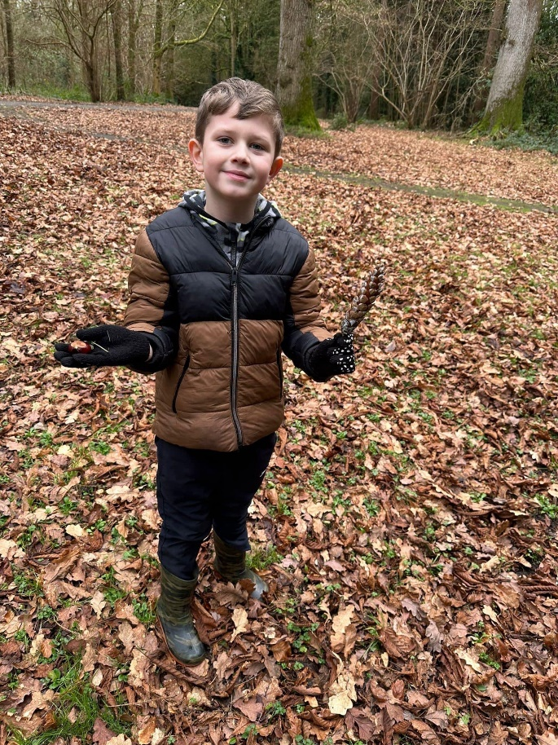

Equal Opportunities Policy
Forest School aims to provide for all pupils regardless of gender, race, ethnicity, religion or disability.
- Promoting a positive, empathetic and valuing ethos.
- Understanding that children have different learning styles and multiple intelligences and striving to accommodate all.
- Working hard to include all, using available resources and seeking expert help and advice as necessary.
- Challenging stereotypical and prejudicial comments or behaviours.
- Supporting those children who experience discrimination and those who, through misguided judgements, discriminate.
- Using opportunities to celebrate the diversity of cultures.
- Exploring opportunities throughout the curriculum to address discriminatory and equality issues.
- Value and celebrate the contributions of all.
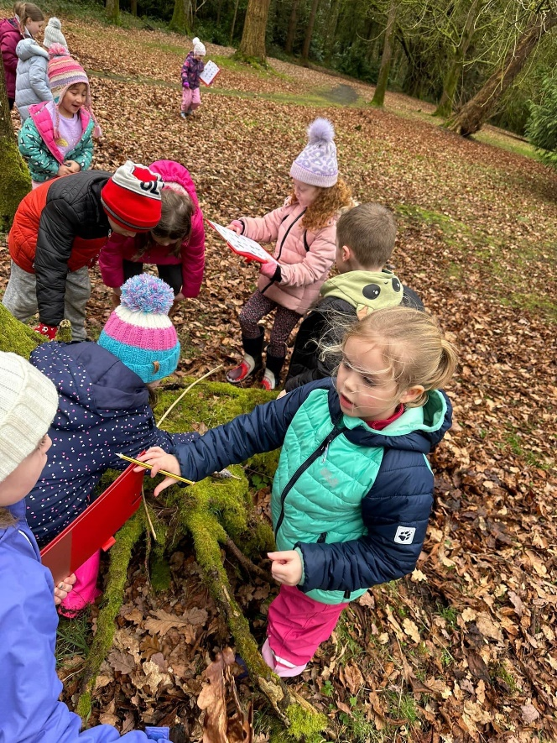

Equipment
Tools
Tools are to be maintained in good order by the Forest School Leaders and inspected before each session to ensure safety.
It is important that during a session all tools are handled properly and treated with respect. To ensure that this happens the following rules should be followed:
- No children should bring any edged tool to any Forest School session.
- No children are allowed to get any tools from the tool box or bag. They must find a member of the Forest School staff to hand them a tool.
- Penknives are to be opened and closed by members of Forest School staff.
- Running with tools is not allowed.
- When walking with tools, saws should be held facing downwards and knives with the blades closed.
- Children may lose permission to use tools if they are misusing a tool.
- All tools need to be counted back into the tool box/bags at the end of each session.
Working with tools:
- When working with penknives, saws, secateurs and billhooks the adult:child ratio should be 1:1.
- Long hair or loose clothing should be tucked away.
- Peelers+knives – always whittle to the side of and downwards away from the body.
- Billhooks – are to be used as cleaving rather than chopping tools i.e. they should not be swung and should never be used with gloved hands.
- Bow saws should have their guards on when not in use.
- Extreme care should be taken that no tool is used to point with.
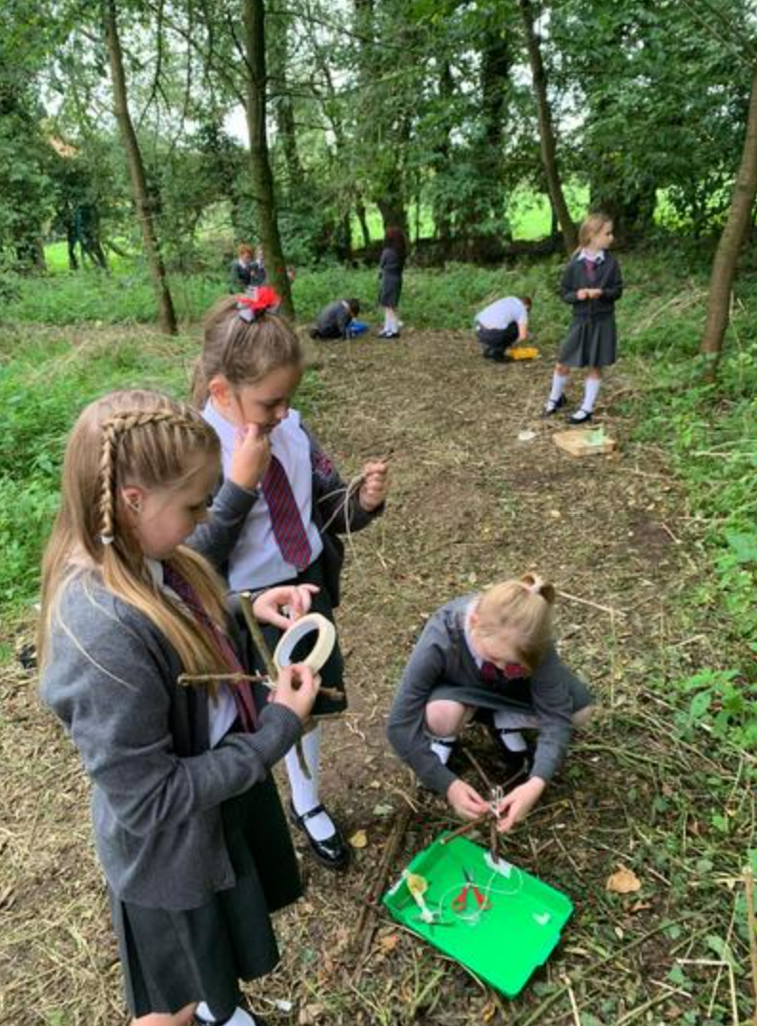

Forest School Leader’s Equipment
- Plastic bags
- Toilet paper
- Trowel
- Register of children
- Medical details
- Accident forms
- Emergency contact numbers
- Whistle
- First Aid kit
- Fire lighting kit
- Mobile phone
- Equipment required for Forest School activities e.g. wool, bamboo canes etc.
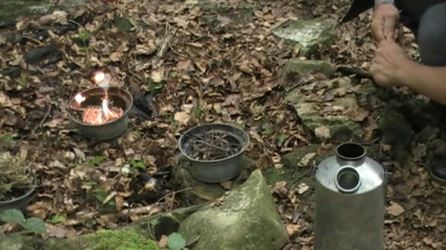
Toilet Protocol
As a volunteer please DO NOT take a child to the toilet. If the child needs help with this they are only allowed to be accompanied by their school teacher, teaching assistant, Forest School Leader or parent who will:
First choice: Visit a toilet which is nearby (123 room)
Second choice: If no toilet is nearby
- Take the trowel and toilet paper and find a secluded area out of the site, outside the boundary for activities.
- Dig a hole about 30cms deep.
- Deposit in the hole (including any loo paper used) and cover with a handful of leaf litter. Fill in the hole with the soil removed at the beginning.
- Wash hands.
Insurance
Markethill Primary School has their own insurance covers them for visiting the woodland and undertaking Forest School activities.

Impact of Forest School on the Woodland
All adults should be mindful of the impact that Forest School has on the woodland. On the school site the following measures are in place to minimise the impact.
- Designated fire pits
- Children are encouraged to stay on the paths for most activities.
Please follow the “Leave no Trace” principles – www.lnt.org/programs/principles.php
When using the woodland, adults and children should be mindful of the impact of lots of feet on the woodland floor, especially on the steeper slopes.
At certain times of the year it may be advisable to avoid certain areas.
The site is rested during the school holidays as Forest School only takes place during the term time.

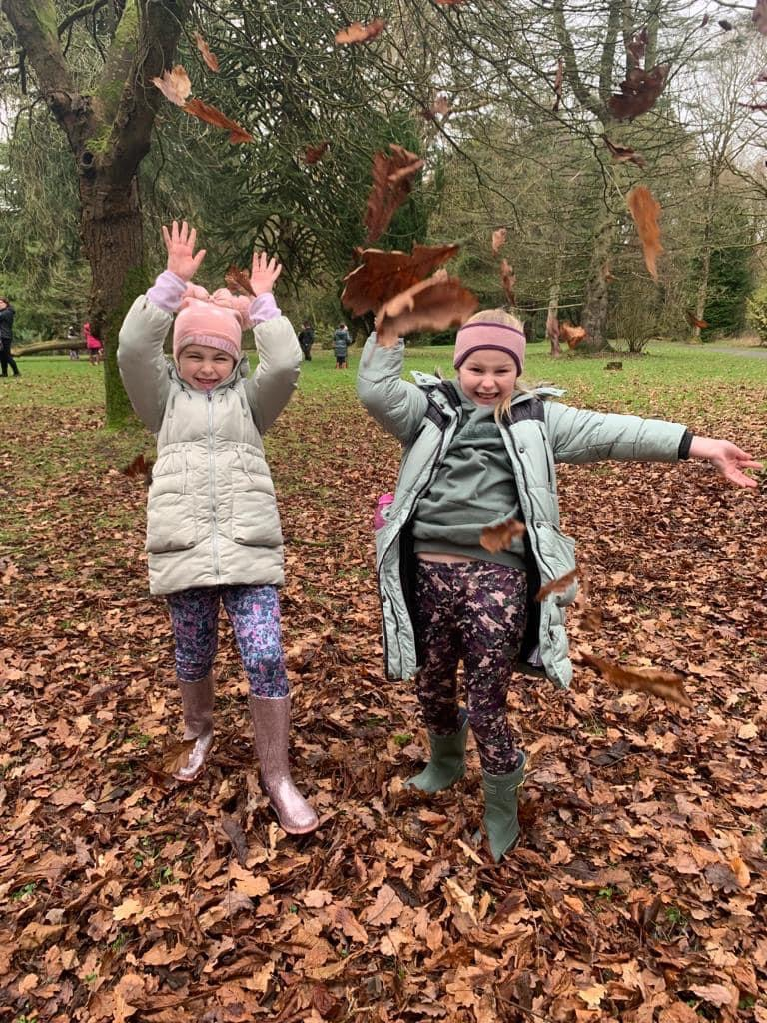

Appendix 1
RISK ASSESMENT FORM
Markethill Primary School
Armagh City, Banbridge and Craigavon Borough Council
Hazard | Assessed by/on | Level of Risk | Short Term Action | Long Term Action
Stinging nettles | FS Team September 2023 | L | Teach children what they look like and tell them to avoid. | Teach children what they look like and tell them to avoid.
Brambles | FS Team September 2023 | L | Teach children what they look like and tell them to avoid. | Teach children what they look like and tell them to avoid.
Ivy | FS Team September 2023 | L | Teach children what they look like and tell them to avoid. | Teach children what they look like and tell them to avoid.
Fungi | FS Team September 2023 | L | Teach children what they look like and tell them to avoid. | Teach children what they look like and tell them to avoid.
Groundsman mowing/strimming | FS Team September 2023 | L | Keep away | Keep away
Visiting cats/foxes/dogs etc. | FS Team September 2023 | L | Remove faeces from areas where children are working | Remove faeces from areas where children are working
Litter | FS Team September 2023 | L | Remove by FS Team prior to session. Advise to avoid. | Remove by FS Team prior to session. Advise to avoid.
Low branches | FS Team September 2023 | L | Vigilance, verbal instruction to children | Remove
Road | FS Team September 2023 | L | Instruct children re safe walking.  Correct ratios.  High visibility vests for adults | Instruct children re safe walking.  Correct ratios.  High visibility vests for adults
Steep slopes | FS Team September 2023 | L | Instruct children  Position adult nearby | Instruct children  Position adult nearby
Rabbit holes | FS Team September 2023 | L | Instruct children  Position adult nearby | Instruct children  Position adult nearby
Uneven/slippery ground | FS Team September 2023 | L | Instruct children  Position adult nearby | Instruct children  Position adult nearby
Puddles (muddy water in eyes) | FS Team September 2023 | L | Instruct children  Care when splashing | Instruct children  Care when splashing
River | FS Team September 2023 | H | Instruct children of danger. Ensure boundaries are positioned well before river bank. Tape off area if required. | Instruct children of danger. Ensure boundaries are positioned well before river bank. Tape off area if required.
Antisocial behaviour | Instruct children of danger. Ensure boundaries are positioned well before river bank. Tape off area if required. | H | Children should be removed from the Forest School site and returned to school if there are any instances of antisocial behaviour nearby. | Children should be removed from the Forest School site and returned to school if there are any instances of antisocial behaviour nearby.

Name of site/activity | Markethill Primary School
Assessor Name | Miss E Gilliland & Mrs R Chapman
Assessor position | Class Teachers and Forest School Leaders
Date | 27th September 2023

NIFSA Risk Benefit Analysis Form
Low Risk | Something which may result in minor damage or slight harm (i.e. scratch or bruise)
Medium Risk | Something which may result in a significant loss/damage or major injury (broken bone or other injury, which results in person being taken to hospital for treatment)
High Risk | Something which may result in extensive damage, multiple major injuries or death

The Hazard | What might happen? | Potential level of risk | Controls | Level of Risk After Controls | Does the Benefit Out way the Risks? | Responsibility
Insects, wasps, plants and fungi | Possible allergic reaction, poisoning, choking | High | - Find out about known allergic reactions within group  - Warn children about wasps  - Discuss poisonous plants and fungi  - warn children not to eat anything or put fingers in mouth - Everyone to wash hands before lunch  - Carry antiseptic wipes. | Low | Yes – Significant benefits to being in a woodland environment. Children learn to respect the environment and about managing own risks in the woodland. | Group leader to know about children’s allergies before entering the woodland.
Animal feces/ mud/ dirt/ etc | Infections in cuts etc | Medium | -Provide wet wipes and water for cleaning hands. - Ensure participants clean hands before eating and at end of session. | Low | Yes – Significant benefits to being in a woodland environment. | Group Leader to ensure hand cleaning provision made.
Medical Conditions | Asthma, diabetes, epilepsy, etc | High | -Find out about known conditions before session | Low | Yes – Significant benefits to being in a woodland environment. Children learn to achieve despite medical conditions. | Group leader to take responsibility for medical conditions of children and to bring equipment eg inhalers.
Lost children | Getting lost, panic attack, potential abduction | Medium | Group stays together at all times.  - Adult at front and back of group when moving through woodland.  - Predefined area for children during woodland activity.  - Count children regularly | Low | Yes – Significant benefits to being in a woodland environment. | Group leader to do safety talk at start of session Adults to count and check children throughout visit
Weather (hot, cold, wet) | Sunstroke, sunburn, hypothermia, cold | Medium | Ensure children are wearing appropriate clothes.  - Ensure children have sun-cream.  - Ensure children are warm enough  – encourage physical activity. | Low | Yes – Significant benefits to being in a woodland environment. | Group leader to ensure children are appropriately dressed Adults to keep an eye on children’s condition.
Forest Operations | Fall from stacked timber; trips and slips; collision with forest machinery | High | -Safety talk to be given at start of activity.  - Don’t climb on stacked timber - Warning signs to be read and followed when operations occurring  - Ensure adequate adult Supervision  - Inform Forest Owner about visit in advance | Low | Yes – Significant benefits to being in a woodland environment. | Group leader to inform Forest Owner in advance of visit and to do safety talk  Adults to read and follow safety / warning signs
Slippery paths/ uneven surfaces  Falling trees/falling dead branches/branch face whip/poke in the eye/slipper logs | Possible injuries to limbs/eye and falls | Medium | - Make children aware of uneven ground, watching steps. Talk through animals creating holes and rocks etc  - Boundaries where needed  - Digging isolated to one area to limit holes.  - Boundary flags to keep children within suitable area.  - Maintenance of area e.g. giving land time to re-cover.  - Limit running through uneven/slippery ground  - Adult to supervise groups | Low | Yes -Gross motor, balance and co-ordination improved  Access to enriching environment. | Group leader to do safety talk at start of session
Behavioural issues | Injuries to self, others or forest area. | Medium | - Follow school behaviour policy  - Positive approach  - Set expectations at the beginning of sessions  - Use of boundary flags and forest school rules  - Appropriate adult to pupil ratio  - Risk assessments for individual children receiving behavioural support  - Possible limitations on activities/access/use of equipment depending on child.  - 1-1 use of tools until shown maturity, skills and independence to use on their own. | Low | Yes – low chance of misbehaviour in setting. Significant benefits of being in woodland environment especially for children who require sensory input. | Group leader to do safety talk at start of session, ensure boundary flags are in location, ensure appropriate ratio and follow policy.
Incorrect use of tools | Cuts, slices, amputation | High | - Trained forest school staff observing as tools are being used  - Tool talk delivered by trained staff -Children to give the tool talk themselves before they are allowed to use them - Tool talk covers: use of tool, how to carry it, pass it, put it down, store it, safe working distance from other children.  - Use of PPE/protective clothing where necessary  - Ensure tools are properly maintained with the safety guards applied. | Low | Yes - teamwork, concentration, accomplishment, following instructions, survival skills, respecting the environment, problem solving. | Group leader to do safety talk at start of session, trained leader to observe use of tools and ensure children are of appropriate maturity and skill if allowing to use in adults site independently otherwise this should be done on 1-1 basis.
Maintenance of tools | Cuts, slices, amputation | High | - Checking tools during ‘tool talk’ before every use  - Regular maintenance of the tools  - Practitioner to check tools when taking them out of the tool chest. | Low | Yes – maintenance of tools can be easily managed and allows safe tool use. Benefits of tool use outlined above. | Group leader should check tools before session, report (to a qualified forest lead) and remove any tools which are no longer in condition for use. If unsure check with qualified forest school lead.
Lack of access to First Aid | Increase to severity of injury, panic attack. | High | - First aid available in 123 room  - First aider available during sessions  - Multiple staff members are trained in first aid and available throughout.  - On site so more help can be sought after if/when necessary. | Low | Yes – significant benefits of being in woodland environment, chance of serious injury is extremely low. Cuts and scrapes can be easily cleaned and are minor in comparison to the overall enjoyment and skills within forest school sessions. | Group leader should ensure they have a qualified first aider with them at their session. First aider is responsible for administering first aid.
Fire spreading from fire pit/discarded glass | Burns, smoke inhalation. | High | - Regular litter picking  - Fire sessions isolated to one area in old washing machine drum to contain it  - Fire sessions limited to older children (P4-7)  - Adult supervision throughout use of fire pit/tools  - Adult extinguish fire appropriately after use  - Use of heatproof gloves.  - Water kept beside fire while lit in case of need  - Make children fire aware and aware of meeting point if teacher blows whistle 3x – in front of infant fenced outdoor area  - Fire blanket/fire extinguisher accessible (123 room)  - Stay out of the fire circle unless invited by an adult  - Assume the correct position when tending to a fire | Low | Yes – chance is extremely low when managed by a trained practitioner. Use of fire skills develops:  Responsibility, teamwork, land management knowledge, perseverance, learning how to be safe around fire. | Qualified forest school lead responsible for supervising fire use.  Group leader is responsible for checking site prior to use and giving safety talk to make children aware they need to report any rubbish/glass found and not to touch it.
Hot water/Kelly kettle/ hot equipment after use. | Burns, Scalding. | High | - Use of heatproof gloves  - Only adults use the equipment  - Follow tool talk guidelines  - Adult supervision  - Kettles checked to make sure handles are in good working order prior to use.  - Safety talk with children prior to use  - Children not to enter fire circle unless invited by adult. | Low | Yes - Use of fire skills develops:  responsibility, teamwork, land management knowledge, perseverance, learning how to be safe around fire. | Qualified Forest School Lead responsible for supervising and ensuring safety talk is completed/rules followed.
Sparks from fire | Burns. | High | - Safety talk with children prior to use  - Children not to enter fire circle unless invited by adult.  - Adult supervision  - PPE/ heatproof gloves  - Use of appropriate fire lighting equipment in clear area (some rocks are not safe near fire) | Low | Yes - Use of fire skills develops:  responsibility, teamwork, land management knowledge, perseverance, learning how to be safe around fire. | Qualified Forest School Lead responsible for supervising and ensuring safety talk is completed/rules followed.
Dumped rubbish | Cuts, trips, attraction of rodents, infections to cuts etc | Low | - Regular litter picking/checking/maintenance of site  - Due to location, this is unlikely (in private school grounds)  - Make children aware of rubbish and not to touch but alert an adult. | Low | Yes - Significant benefits to being in a woodland environment. Children learn to respect the environment and about managing own risks in the woodland. | Group leader is responsible for checking site prior to use and giving safety talk to make children aware they need to report any rubbish/glass found and not to touch it.  Qualified forest school lead responsible for ensuring regular litter picking/ maintenance of site.
Dog loose on playground | Bite from dog, injury if knocked by running dog, panic attacks. | Low | - Follow “Dogs on School Grounds” policy  - Contact Local council dog warden if stray  - Contact owner if not  - If safe to do so bring children indoors to school or 123 room until dog has been removed | Low | Yes - Significant benefits to being in a woodland environment. | Group leader responsible for implementing Dogs on School Grounds policy.
Dangerous weather | Increased risk of slips, falls, trees/branches falling. Lightning causing fire, burns. Sunburn, hypothermia. | High | - Visual and online check of weather prior to entering site  - Check of site to ensure it is appropriate for use (no large amounts of flooding/marsh, no loose branches or trees etc)  - Ensure children have appropriate clothing before entering site  - Ensure children wear suncream/hats when needed  - Follow “what to wear to forest school” on NIFSA website e.g. no scarves recommended. | Low | Yes - Significant benefits to being in a woodland environment. Children learn to respect the environment and about managing own risks in the woodland. | Group leader responsible for checking weather prior to visiting site. If unsure – check with qualified forest school lead.
Use of string/rope | Rope burns, strangulation, hanging. | High | - Safety talk with children  - Children only use rope/string to tie a knot they have been shown how to use  - Appropriate clothing  - Children shown how to handle rope safely e.g. not pulling fast as this will likely cause the rope to burn hands  - Adults supervise and ensure the rope is not biting into the trees | Low | Yes – use of string and rope to create, attach and build allows children to develop:  - Teamwork  - Concentration  - Accomplishment  - Following instructions  - Survival skills  - Respecting the environment  - Problem solving | Qualified Forest School Lead responsible for supervising and ensuring safety talk is completed/rules followed.
Manual Handling | Straining to muscles/sprains/injury to back, scrapes, bruising, drop on limb. | Medium | - Encourage to assess weight before moving anything  - Try dragging or rolling the item rather than picking up  - Ask for help from other children  - Bend knees before picking up | Low | Yes – encourages awareness and develops wellbeing of self and others | Qualified Forest School Lead responsible for supervising and ensuring safety talk is completed/rules followed.
Slack Line | Laceration, falling. | High | - Slackline attached and checked it is  - safe to use as directed in instructions  - Participants shown how to use the equipment safely in line with the manufacturer’s guidelines  - Practical clothing and footwear to be used  - Slackline to be no more than 30cm from the ground to reduce risk of injuries from falling  - When on the slackline, two children to support (either side) to support and reduce risk of falling  - Equipment and children monitored during the session | Low | - Yes – slack line encourages:  - Caring for the environment  - Teamwork  - Balance and co - ordination  - Physical wellbeing | Qualified Forest School Lead responsible for supervising and ensuring safety talk is completed/rules followed.
Tree Climbing | Falling. | High | - Children to have 3 points of contact with the tree at all times  - Climb no higher than twice their own height  - Trained forest school practitioner to observe | Low | Yes – tree climbing encourages:  - Awareness of body  - Concentration  - Developing a sense of adventure  - Caring for living things | Group leader responsible for safety talk with children and supervising children during activity.

NIFSA Environmental Impact Form

Name of site/activity | Markethill Primary School Conservation Area
Assessor Name | Miss E Gilliland and Mrs R Chapman
Assessor position | Class Teachers, Forest School Leaders (Level 3)
Date | 27th September 2023

Activity Impact Matrix Introduction:
When considering the impact of your Forest School activities it is important to consider the different areas of the Forest. The easiest way to do this is to consider the vertical structures of the woodland. You can use the table below to help consider the impact of your activities.
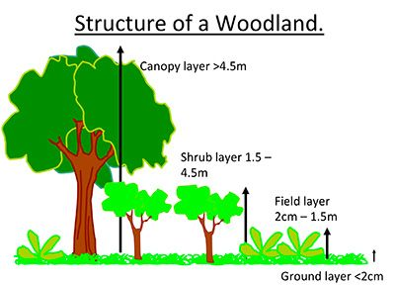
Environmental Impact Key:
Area impacted – see Structure of a Woodland – Canopy, Shrub, Field Layer and Ground Layer
Positive and Negative Impact – will your activity be detrimental to biodiversity?
Permanent/Short term – will your activity have an impact over months, years or decades
Actions – what can you do to lessen eh negative impact
Responsibility – who will make sure this happens

Activity | Area Impacted | Positive/Negative Impact | Permanent/Short term | Actions | Responsibility
Path and clearing  creation – currently  over grown site.  Grass/shrubs will be  cut back. Regular use  will reduce growth. | Ground Layer/Field Layer N, S, R Plants maybe lost. However, some wild growing areas will be left. If left to regrow should recover. | Negative impact | Temporary (1-2 months)  Will regrow but trampling will keep the paths accessible. | Only clear those areas that need to be cleared.  Remove all the cuttings offsite. | Forest School Development Officer
Litter Picking – Area always checked by adult first to ensure the nature of the environment. | All Layers P,S,Temp Litter removal good for flora and fauna. Due to the area litter will return. | Positive impact – harmful litter being removed | Temp – regular litter picking by adult prior to forest school sessions and Eco club reps. Due to the area litter will return. | Regularly litter pick. Adults check site and clear litter prior to Forest sessions. Children encouraged to look after environment and alert adults if they see litter. | Forest School Development Officer
Shelter Building | Ground/Field Layer N,S, R Trampling of Flora/Fauna as site is used. Braking of leaves and branches during building. Area should recover when left.  Understory N, S, R Braking of leaves and branches during building. Area should recover when left. | Negative Impact | Reversible | Reduce size and number of dens built.  • Create a pile of den building wood  that children know is OK to use.  • Create other dead wood piles on site,  and agree with the children that  these are for wildlife habitat, not den  building | Forest School Development Officer
Fire Lighting - Whether in small groups or one large Fire. Ensure set up and cleaning are supervised. | Ground Layer N, M, P/R Logs/twigs burnt, ash left on ground layer. Burnt wood will replenish. If fire area cleared correctly ash should be unnoticeable and eventually will degrade  Field Layer N, M, R Field Layer Areas maybe cleared for fire. Area would recover in time.  Other Layers N,M,R Fires lit under tree cover may mark trees or damage above branches. These area will recover in time | Negative Impact - leading  to burnt  vegetation and  change in  chemical  composition of  soil. | Reversible | Enclose fire pit so fires are well  contained, or use a fire bowl.  • Limit the frequency of fires to allow  soil to recover.  • If the site is large enough, rotate fire  locations. Fires should be at least 4  metres from surrounding trees.  Reduce amount of firewood collected.  • Consider buying local firewood  from sustainably harvested sources  instead, or ask for donations.  • Encourage the creation of new dead  wood habitats on site and agree  with the children that these are for  wildlife, not firewood. | Forest School Development Officer
Bow Saw - Cutting of ground wood and collecting of appropriate branches | Ground Layer N, M, P/R Collection of wood for cutting, would replenish in time. Movement of ground layer for cutting area.  All Layers N/P. M, T When collecting wood for cutting some branches, trees maybe felled. Although this is negative ground layer will receive more sunlight allowing new plants to thrive. | Negative Impact | Reversible | Space out sessions involving use of bow saw so area has time to recover.  More sunlight will reach ground level to promote growth of new plants. | Forest School Development Officer
Digging soil/ Mud Kitchens | Ground Layer – N, M, P/R  Digging in soil can damage soil structure and could remove/damage tree roots however, time will be given for area to recover and roots will | Negative impact -  can damage  soil structure  and tree roots. | Permanent/reversible | Contain area of digging and reduce  frequency of activity.  • Move areas of digging away from  tree roots.  • Replant/resow areas of digging to  allow plants to regrow.  • Talk to children about how to look  after bug life in the soil and any  plants that they find.  • Identify tree roots and talk to  children about the role of roots and  how we can protect them. | Forest School Development Officer
Breaking tree branches  through play, tree swings,  ropes and slack lines. | Shrub Layer – N, P/R – accidental breaking of tree branches | Negative | Permanent/ Reversible | Talk with children about how to care for and look after the tree and why.  • Remove swings from any damaged branches and engage a tree surgeon to advise on tree health.  • Take down ropes at the end of each session for the safety of other users of the site, and protection of the tree. | Forest School Development Officer
Bark damage: bark stripping  through play, and/or damage  through tree swings, ropes  and slack lines. | Shrub/Field Layer – N, P/Temp – accidental damage to tree through play | Negative | Permanent/ Temp (depending on damage) | Talk with children about how to care  for and look after the tree.  • Engage a tree surgeon / arboriculturist  to advise on tree health.  • Buy or make tree protectors that pad  between the tree and the rope/slack  line.  • Take down ropes at the end of sessions  for safety and tree protection. | Forest School Development Officer
Pruning fruit trees to promote new growth, more blossom for insects and improve fruit yield. Planting new fruit trees to increase food for pollinators, birds and other wildlife. | Canopy Layer – P, L – purposeful maintenance of area | Positive | Long term | Engage with local volunteer groups  who may have knowledge to share.  • Harvest a share of the fruit (leaving some for the birds!) and share amongst school community or use in Forest School activities. | Forest School Development Officer
Creating new deadwood  habitats for insects including  bees, small mammals  including hedgehogs, and  other animal life. | Field/ Shrub Layer – P, L – purposeful teaching and learning to positively impact environment | Positive | Long term | Engage children with creating new  habitats from deadwood piles and old wood.  • Research how to encourage different types of wildlife through habitat creation on your site.  • Survey wildlife with the children to show the positive impact the new habitats are bringing. | Forest School Development Officer
Heat from fire damaging tree  canopy | Canopy Layer – N, P/R – heat from fire directly damaging canopy layer | Negative | Permanent/ Reversible | Light fires at least 4 metres away  from large trees and any overhanging branches.  • Reduce frequency of fires / spread locations to reduce impact. | Forest School Development Officer

Contact Number Sheet
Please keep this sheet updated and take out for every Forest School session)

MArkethill Primary School Details
Markethill Primary contact - 02837551589
Principal Mobile (Helen McLernon) – 07980 012426
Vice Principal Mobile (Roberta Chapman) – 07753604550
Forest School Co-Ordinator (Emily Gilliland) – 07507 308172
Forest School Teacher Mobile (Roberta Chapman) – 07753604550
Forest School Classroom Assistant Mobile -
Northern Ireland Forest School Association Details
Forest School Leader – Brian Poots – 07790884522
Accident & Emergency Details –
Nearest Accident & Emergency Hospital – Craigavon Area Hospital - 028 3833 4444
Site Details – Markethill Primary School Conservation Area
Armagh Borough Council – Biodiversity Officer – Lindsay Matthews – 07876352848
Armagh Borough Council General number - 0300 0300 900

